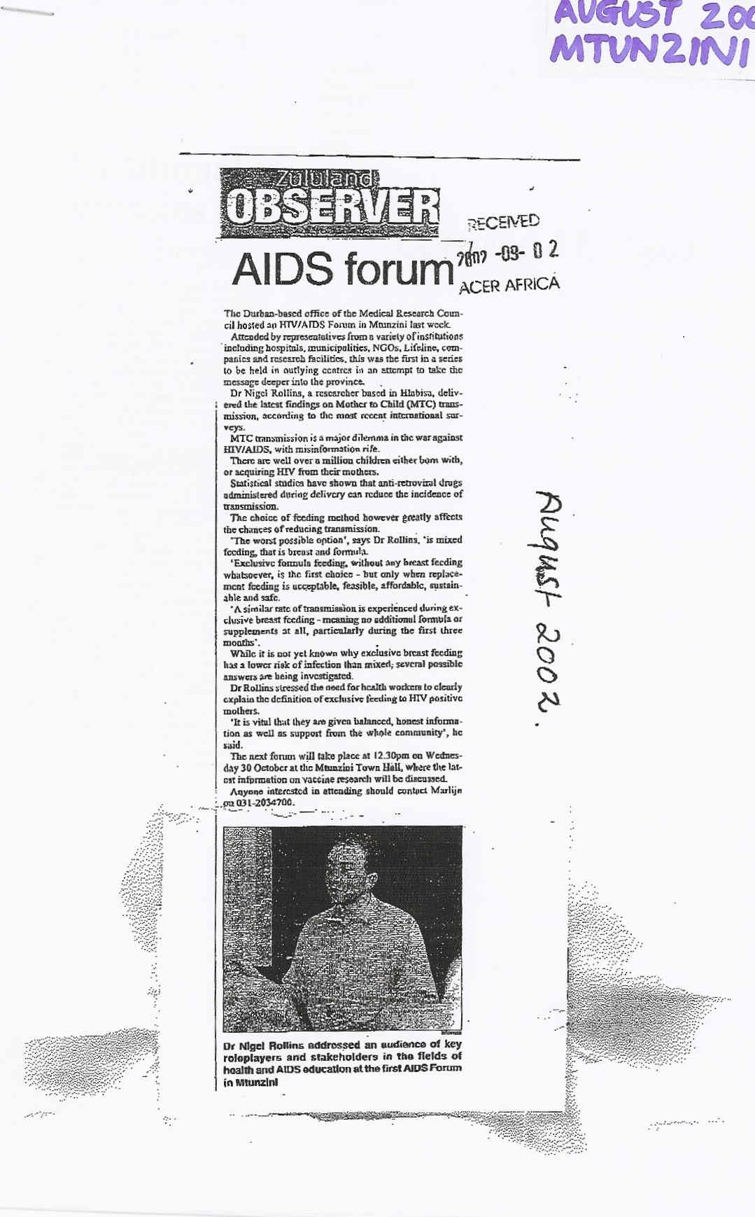
AUGUST 2002 MTUNZINI

