HISTORY OF WOZA MOYA/ HILLCREST AIDS CENTRE

The initial vision of the centre/ Methodist Church was to assist men and women affected by HIV by providing palliative care at patient’s homes. However working practically it became clear that in order to sustain the benefits patients received from Home based care and the benefit of nutrition from the feeding scheme a long term plan needed to be put in place. It was then the idea and the necessity of having an income generation project became our next goal. However it was clear that as most of the clients we worked with had no marketable skills and that the income generation project would have to provide training to equip our patients with the necessary skills to earn an income.

The income generation project provides our patients with skills that reduce their dependence on the centre. As well as creating a more positive outlook on life in all those who come into contact with the centre. The centre now offers a holistic program of care and support. The vision of the centre has always been to follow opportunities/dreams that have shown themselves.

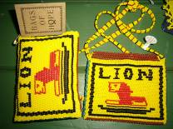
Just a bit of fun!

General Description

WOZA MOYA INCOME GENERATION PROJECT

Woza Moya is a self- help project initiated by the Hillcrest AIDS centre, as part of a holistic care program. Clients, who are either affected/infected by HIV, are referred to either the feeding scheme or the income generation/horticulture project by the nurses, depending upon the client’s state of health and family demands. The centre found it was possible to improve quality of life of our clients though access to nurses, medication and home based care but this is not sustainable without a regular income, hence the birth of the income generation project. The feeding scheme is a short term intervention until some form of income generation training has taken place.

The project aims to uplift people affected/infected by HIV/AIDS. It helps men and women regain hope and dignity by getting them to use their creativity to earn an income. At present Woza Moya acts as an agent for over 100 crafters. As the AIDS epidemic increases more families are turning to us for help and we assist them by offering training in beadwork, wirework, ceramics, fabric-painting, crochet and sewing. The centre then markets the goods for them. We endeavor to give our crafters the best possible price for their goods so that they have a regular, sustainable income. The shop puts on a maximum 30% mark up so that the crafter receives the majority share, but each crafter is evaluated and the mark up can be as little as 5%.

We are a dynamic and creative organization whose primary focus is beadwork (we specialize in beautiful beaded AIDS ribbons); we have two sewing groups, a ceramic group, a wonderful fabric painting group who make anything from ethnic inspired table cloths and cushion covers to conference bags, a crochet group which takes on large orders, as well as a wirework group which produces assorted custom made wirework.

We enjoy designing new products and try to keep ahead of current trends, we have also endeavored to make our own patterns and style so as not to take work away from our traditional beaders.
All our crafts can be made to client specification

As we are a charity (TRUST) based organization, none of this would be possible without our team of dedicated teachers who donate their time and talents to run the various groups and workshops.

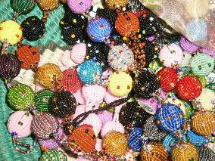

THE NITTY GRITTY

CONIVE SCHEME AND DRAW UP CUNNING PLANS

- Brainstorm:
- Look at the year ahead and ask yourself where and what can I sell? I started with the obvious- Christmas and Valentines Day. Look at one of your products - you want to sell lots. Ask yourself where can you access large groups of people- schools are a good place to start- corporate's will only use you when you have built up some street credibility.
- Focus then more specifically in your area, at your local community, i.e. Schools and Churches, what important days are they having, Palm Sunday, 100 year anniversaries. Approach them with your well designed concept, you want it to be easy for them to be say yes and difficult for them to say no. I give them a written order form so all they have to do is photocopy it and hand it out.
- Once you are in one scheme start the next one rolling, otherwise you will be left with no work once plan A is in action. I feel it is a bit like juggling, keeping many balls in the air but focusing on the one in your hand intently.
- Don’t be disheartened, there is only a 10 % comeback – if you send out 100 faxes only 10 people will answer, therefore keep communication cheap.
- I do a lot of marketing through the internet, which is cheap and time efficient.

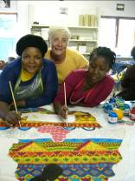
Two of our special fabric painters, and Inga a retired textile designer who volunteers her services to the centre working on a banner for Gap International

NEW PRODUCTS/PRODUCT DESIGN

- It is crucial to make something that people want.
- Keep it simple. To begin with get one product right first, make it special or different, or offer a choice. We started with AIDS ribbons but made ribbons no one else made- It can be that simple.

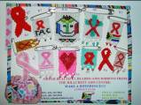
Our AIDS Ribbons- a magnet I made and sent to AIDS organizations – very primitive!
- My tack has been to make a variety, as I had to make an immediate income for a large group of people at once- so we could not specialize. When I started the project it was just me, marketing, selling, designing, phoning!!! sometimes I did not kow what I had to do next! It has had its own problems as we made fabulous products but they were not marketed well, as I did not have enough time to sell each product in itself. We are now known as a place with gifts- people have a big choice. A lot of the craft items we make have been experiments- if they sell we make more, if they sit we don’t do them again.
- Inspire the crafters, we all need inspiration, I sit with my top crafters individually and we have a fabulous time looking at magazines, going on excursions, going online, there are some fabulous American beading sites. As. I am running many groups at once I have to watch them too if I feel the work ethic has dropped or the quality has dropped or stagnated it means that they are unhappy and then I do something. A drop in quality means morale is down. If I can’t inspire them then I find someone who will do it for me, usually a friend or old student who is good at something- and I rope them in to do the inspiring or it can be someone that I recently met and they are looking to give back to the community, sometimes they just need to make something. for themselves. This has been wonderful to watch how a bad situation turns into a marvel.

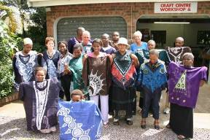
A group of Nigerian Textile artists who I met and then came to the centre to teach our crafters- very inspiring!

- The products come from the crafters so you have to have a good relationship with them and there has to be a good deal of trust, as making something new can be a flop. I remember working on a necklace with one of the beaders for half a year trying to get it right. Sometimes your idea and the crafters idea can’t meet, most of the time I find a happy accident occurs, it is part my idea and part the beaders- turns out much better than we both imagined.
- I keep designing new products every week. I also listen to my customers. If they keep asking for something then I try it. The customers also feel like the shop is theirs now as they have contributed a thought which has been acted on.
- I feel our success has been in the power and healing of making something beautiful, every single thing to me holds beauty. The beauty of watching a beader light up when she hands in her work, because of a wonderful sense of pride in making something beautiful, this never ceases to bring me joy.
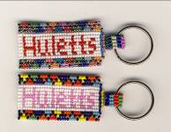
A key ring designed for a corporate client

PRICING
- Pricing I have always had a range of prices, some things customers feel they are getting a bargain and other items are more expensive.
- I insist that the beaders make a price for their goods, when we first start off they are very shy, so I play a game I say R2 and they gasp in horror, and so we go on until they are happy with the price we have negotiated. I have a pricing structure for most items which makes my life easier. We also look at how many beads it took the time, so I try to get them to think about all the factors that come into play when making something.
- Sometimes I get an order and the customer has a ceiling for pricing, I go to the ladies and say what do you think- do you want the work or not. The lowered price that the beader receives only stands for that order. The crafters can decide for themselves.
- If you under price and your beaders are not with you, your order will not be done, and then you will have a problem.
- I have always found a place between shop prices and street vendor prices, as you don’t want to alienate customers who feel you are ripping them off.

SAY YES

- When you first start out you cannot afford to say no, you have to build up what I call valuable street credibility, then you can say we did and order for so and so, and people go really they must be good!
- If you cannot do the order find someone who can, and know your limitations if you know you are going to struggle get help from the start until you are on your feet.
- I have learnt some wonderful lessons from the Zimbabwe wireworkers, every wireworker is connected they are a brotherhood, they share every order they get and that is why they are so good, they will never let you down and, their orders are never late because of this brotherhood. They are one of the most amazing groups of crafters I know, they surprise me with their ability to share and see the bigger picture. They also suffer terrible hardships as they do not have access to ARVS, the centre assists many of them to access treatment and supports them when they are ill. They are also separated from their families and have to live two lives so to speak supporting huge families in Zimbabwe. Just looking at them and how they are successful helps one immensely as they adapt, change with customer demands and have fresh ideas continuously.
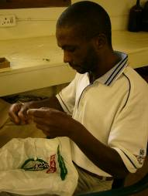
One of the wireworkers

PACKAGING
- I have never really worried about packaging until recently as it is too expensive and it gets dusty! I do package big orders and ensure I have my card or sticker on the item.
- Make a card or sticker with your phone number on it; if there is no money Photostat, they have to be able to reorder.
- I make a flyer to put on every packet, with things I need on it, its free advertising.

SELL A SERVICE
- You need to offer peace of mind to your clients, you have to meet deadlines. I refuse to let down clients and will do the work myself if I have to! I have made it a personal guarantee. I have a wonderful beader who I can rely on to take up the slack as he has a sub business he employs 5 beaders that he has trained up, and I can phone him and say I need this tomorrow and it is done. I reward him by every now and then giving him the entire order to handle on his own where he can make a bigger profit for himself. I also pay him better than some of the other beaders as he makes all my samples so I need to keep him happy. He has transformed into a real business man and arrives at the centre on a Friday with his briefcase and diary. He has become a true artist.
- I offer a free repair service on all goods made at the centre.
- Go the extra mile for every customer; word of mouth is better than any marketing. We had a lot of obstacles when we started out – we weren’t allowed to advertise, we had to rely on word of mouth. Some customers just like to pop in for a chat!
- Offer a dream, inspire your customers about your project, all the people I have met want to go the extra mile for the centre, sometimes it is one person who can make an incredible difference I have three people I met at the centre who have returned overseas and sell our goods because they are passionate about the cause. One medical student came over as a volunteer he went back and has sold R150 000 worth of goods in four months!
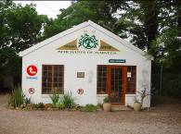
Our humble shop which was a dusty double garage- no ceiling, no floors!

KNOW YOUR BEADERS

- I get to know each beader personally, her husband and children. When they come in to bring work I make sure they are well and if they are not I refer them to the nurses who will treat them immediately. A lot of women leave their illness because they are too busy caring for everybody else. If they have been sick and then don’t return I go and find them, they usually need to go to hospital so the centre is vital in keeping these crafters healthy.
- Know what each person is best at, this may take many years- I make them take ownership of a design and they are responsible for it – it is named after them if they have been central to its design, i.e. rose spiral, happiness’s string. Esters travelers. If their design is popular and it takes off, they get the orders, if it becomes too much work for them; I get them to train up someone else to help them. If they design another new product they stop making the old product and only make the new one. I have had problems with this as when the core person is sick or dies it leaves a gap. I feel this approach adds value as they are rewarded with monetary gain. They are also rewarded by ownership of a product. It gives worth to their skill. It also allows those who are creative to be rewarded.
- Don’t give up on anyone I have had one women who has been in every group and was appalling at everything until she told me she could crochet, she had crocheted all her life- and is one of the most awesome crochet ladies I have ever seen.
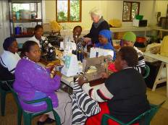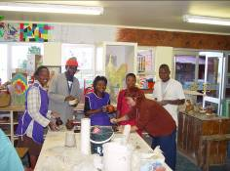
Our first sewing group, and our first ceramic group run at Kearsney college

PASSION/ GOODNESS OF THE UNIVERSE.
- I have to say that this job is my life; there is never a moment that I am not doing my job! I suppose I am very boring to my friends and I most probably sound like a vitamin salesman. Looking back we have come a long, long way, there were some very difficult obstacles, no shop, no money, short staff, no space/place for training, not allowed to advertise, losing a crafter to illness. For me every problem is an obstacle that needs a creative solution. I
- I love working with the crafters, I love seeing the new things they make, seeing them grow and blossom into powerful strong beings.
- My staff are fantastic! I have three permanent staff. I only have money for two so my third staff member has to make her own salary by selling white elephant which I asked people to start bringing in. I have roped in a lot of volunteers who take on the running of the new projects and make sure everything runs smoothly.
- We have been very blessed, and have received donations when we really needed them.

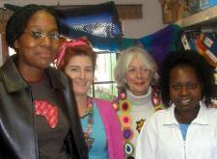

The Woza Moya Team, Silindile, Paula, Jilly and Hlengiwe

Paula Thomson
Craft Co ordinator

